**Actividad de consolidación**

1. Para resolver este ejercicio debe usar el texto del último ejercicio del apunte de clase.

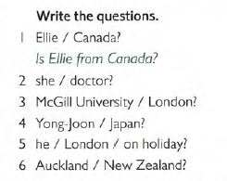

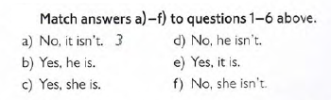2.

3. Look at the texts again and underline the correct option.

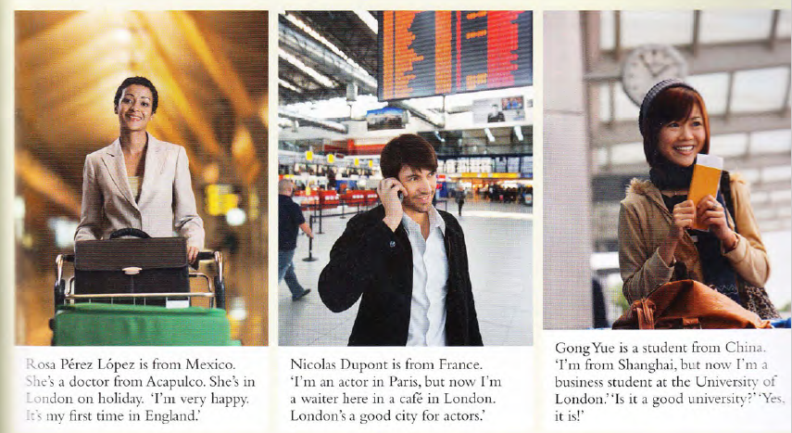

Example:

Rosa Pérez **is** / isn’t from Mexico.

1. Rosa is / are a Doctor.
2. Rosa is / are very happy.
3. Nicolas Dupont are / is from France.
4. Nicolas is / isn’t a doctor.
5. Nicolas is / are a waiter in London.
6. Gon Yue is / isn’t a student from Japan.
7. She are / is from Shanghai.